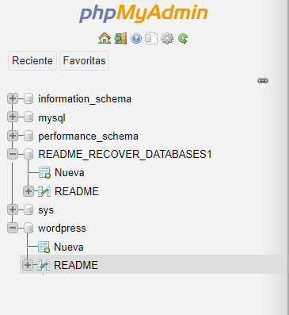

To recover your lost Database send 0.016 Bitcoin (BTC) to our Bitcoin address: bc1qqfe7mk2fa9lelcpm7rjvlls6x4735z9k5dmr9f After this, contact us by email with your Server IP or Domain Name and a Proof of Payment (Payment ID). Your Database is downloaded and backed up on our servers. Backups that we have right now: wordpress. Any email without your server IP Address or Domain Name and a Proof of Payment together will be ignored. If we dont receive your payment in the next 5 Days, we will delete or leak your sensitive information.

bc1qqfe7mk2fa9lelcpm7rjvlls6x4735z9k5dmr9f

mysql_recovery2701@proton.me

